How to Enroll Participants with Disabilities Over the Age of 19 Years
Before You Start
- This is a Manager ONLY feature. County Managers are given a choice while entering enrollments to enroll members as an adult volunteer or club member.

- For program participants with disabilities who are over the age of 19, Managers can select the club member role to override the age limit set for youth members.
REMEMBER: When entering enrollments at the Manager level, paper enrollment/consent forms are required and MUST be scanned and uploaded in the approved 4-H Online enrollment.
NOTE: If this is a new member, and they do not have a Family Profile, you will need to click on the Create Family tab and create the Family Profile first before adding the new member.
Steps  - Click on the Members tab in the navigation pane.  - Click on the Create Family link.  - Continue to fill in the required Family fields and click Save.  - Click on 4-H Program to join and click Next.  - Continue filling in required Add Member fields and click Next.  - Continue to fill out the About You Page for the member and click Next. | 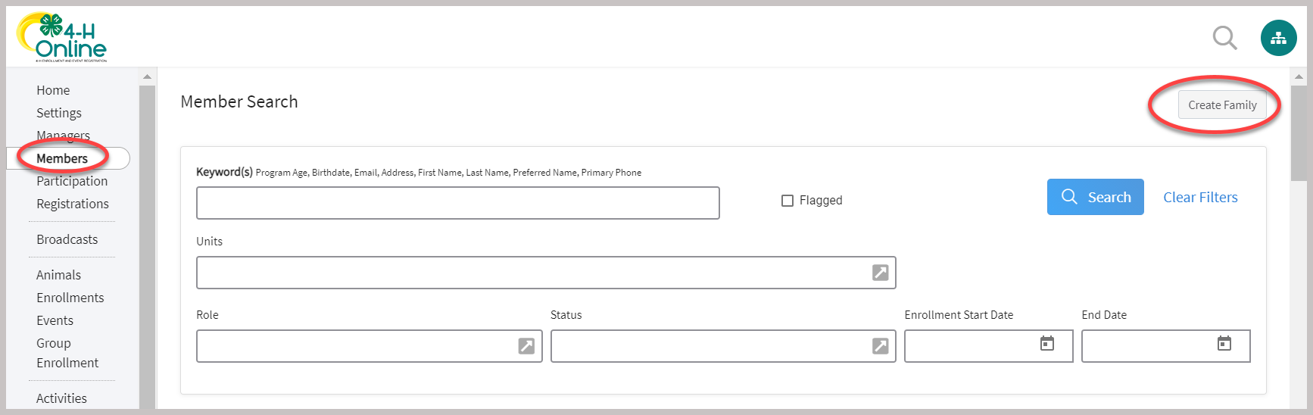
NOTE: The “How would you like to participate?” page is where Managers can override the youth age limits by selecting to join as a Club member.  - Click on the New or Returning 4-H Club Member link to enroll a program participant with disabilities who are over the age of 19 as a Youth Club Member.  - Click Finish | 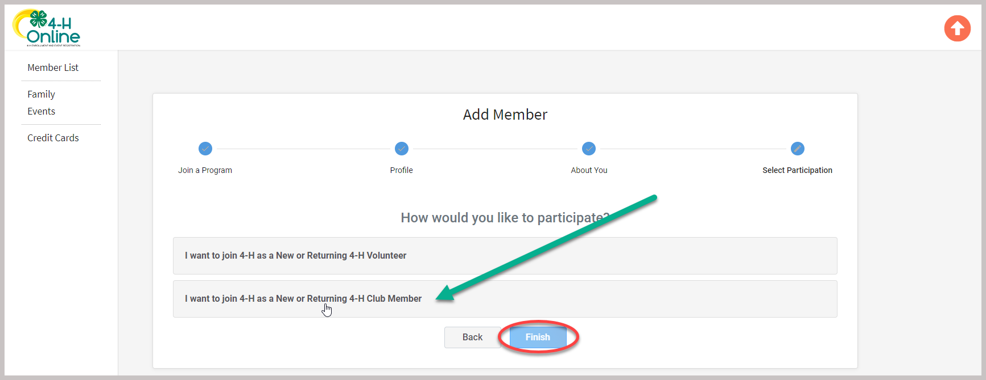
- Continue through the enrollment pages.  - Select the clubs/projects and complete health/consent pages based on the paper enrollment form completed by the parent/guardian.  - Click on Submit | 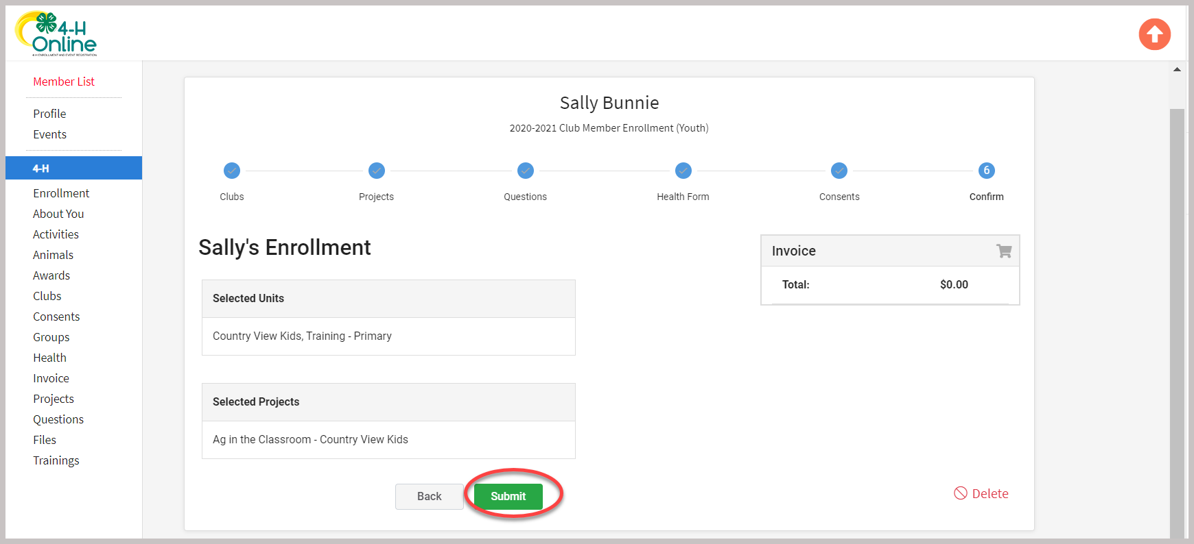
Adding A Member to a Family Profile that already exists:  - Click on a Family from the Members search screen.  - Once in the Family Profile, click on the red Members List link.  - Click on the Add Member blue link.  - Complete the enrollment based on the paper enrollment forms.  - Click Submit | 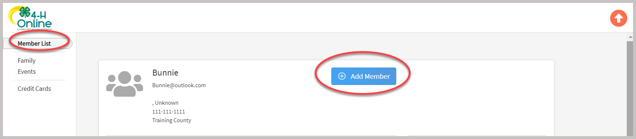
Note: Be sure to select the New or Returning 4-H Club Member role when enrolling program participants with disabilities who are over the age of 19 as a Youth Club Member.
For further assistance, please contact 4-H Online Data Coordinator Shelly Krueger at kruege61@msu.edu

